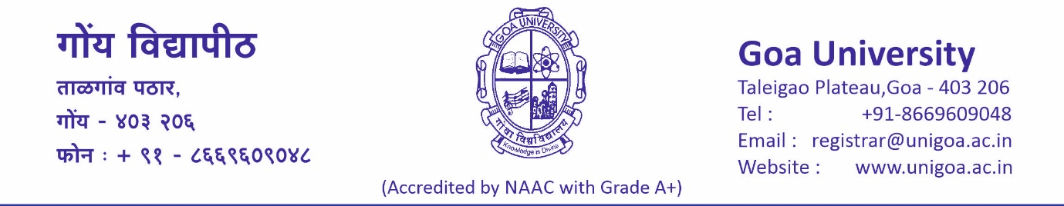

SPORTS SECTION
Tel: 8669609018/8669609075 Email: sports@unigoa.ac.in

PRESS NOTE

Goa University Weightlifting Men Team for AIU’s South West Zone Inter University Weightlifting Men Championship 2025-26

Goa University has selected the Weightlifting Men team for participation at the AIU’s South West Zone Inter University Weightlifting Men Championship 2025-26 to be held at SAGE University, Bhopal (M.P) from 13th to 15th January, 2026.
The kit distribution and farewell function for the teams was organised on 7th January,2026, at Sports Section, Goa University in the presence of Mr. Balachandra Jadar, University Asst. Director of Physical Education and Sports, Goa University, Mr. Dinesh Patil, Assistant Sports Officer, Goa University.
Goa University’s Weightlifting Men team 2025-26:
Student Athlete: Gorakshnath Waifalkar
Coach Cum Manager: -Dr. Ameet Pednekar

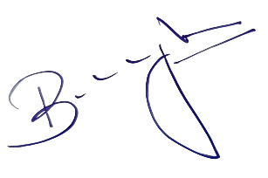

Date: 7/1/2026 (Mr. Balachandra B. Jadar)
Member Secretary-Sports Council,
University Asst. Director of Phy. Edn. & Sports,
Goa University

